Introduction to Git, GitHub, and Google Colab
As a data scientist, your GitHub profile is an important part of your professional portfolio. It provides a place to organize, document, and share your code, projects, analyses, and other technical work. GitHub repositories will be the place where you store and submit all of your work in our class.
Git and GitHub are related, but they are not the same thing.
We will use three related tools:
- Git - is version-control software that runs on your computer. It keeps track of changes you make to files over time.
- GitHub- is an online service that stores Git repositories and makes it easier to back up, share, and collaborate on projects.
- Google Colab- the browser-based environment we will use to write and run Python code.
You could use Git on your computer to make and record changes and then send those changes to your repository on GitHub. However, most of your Python programming in this course will be completed in Google Colab. You will then save your Colab notebooks to your course repository on GitHub.

Step 1: Installing Git
Git may already be installed on some computers. To verify that Git is installed, open your terminal (Mac) or command prompt (windows) and enter:
git --version
If Git is installed correctly, you should see the version of Git installed on your computer. If not, download Git
For Windows: https://git-scm.com/install/windows
For MacOs: https://git-scm.com/install/mac

Step 2: Create a GitHub Account
- Go to: https://github.com
- Create a GitHub account if you do not already have one.
- Choose your username carefully. GitHub is commonly used as a professional portfolio, and you may continue using this account after completing this course.

Step 3: Create Your DATA201 Repository
- After signing in to GitHub, select New repository.
- Name the repository: DATA201-labs
- Select the option to create a README file.
- Create the repository.
A repository, often called a repo, is a location where the files associated with a project are stored and tracked.
This DATA201 repository will be used to store class notebooks and assignments that you create during this course.

Step 4: Open Google Colab
Go to: https://colab.research.google.com and sign in using your Google account.
Google Colab allows you to create and run Python notebooks directly in a web browser. You do not need to install Python on your computer to complete our Colab activities.
Create a New Notebook.
A Colab notebook contains two main types of cells:
- Code cells contain Python code that can be executed.
- Text cells contain explanations, headings, notes, equations, and documentation.

Step 4.1: Run Your First Python Code
- In the first code cell, enter: print("Hello, DATA 201!")
Run the cell by clicking the Run button beside the cell or by pressing: Shift + Enter
You should see: Hello, DATA 201!

- Create another code cell and enter:
x = 10
y = 5
x + y
Run the cell. The output should be: 15

- In cell 3, import the libraries, enter:
import pandas as pd
import matplotlib.pyplot as plt
- Now load the penguins dataset directly into a pandas DataFrame:
url = “https://raw.githubusercontent.com/mwaskom/seaborn-data/master/penguins.csv”
penguins = pd.read_csv(url)

- View the first five observations: penguins.head()
- Suppose we want to answer the question: Which penguin species has the greatest average body mass? Calculate the mean body mass for each species: penguins.groupby("species")["body_mass_g"].mean()

- Visual task: create a scatter plot
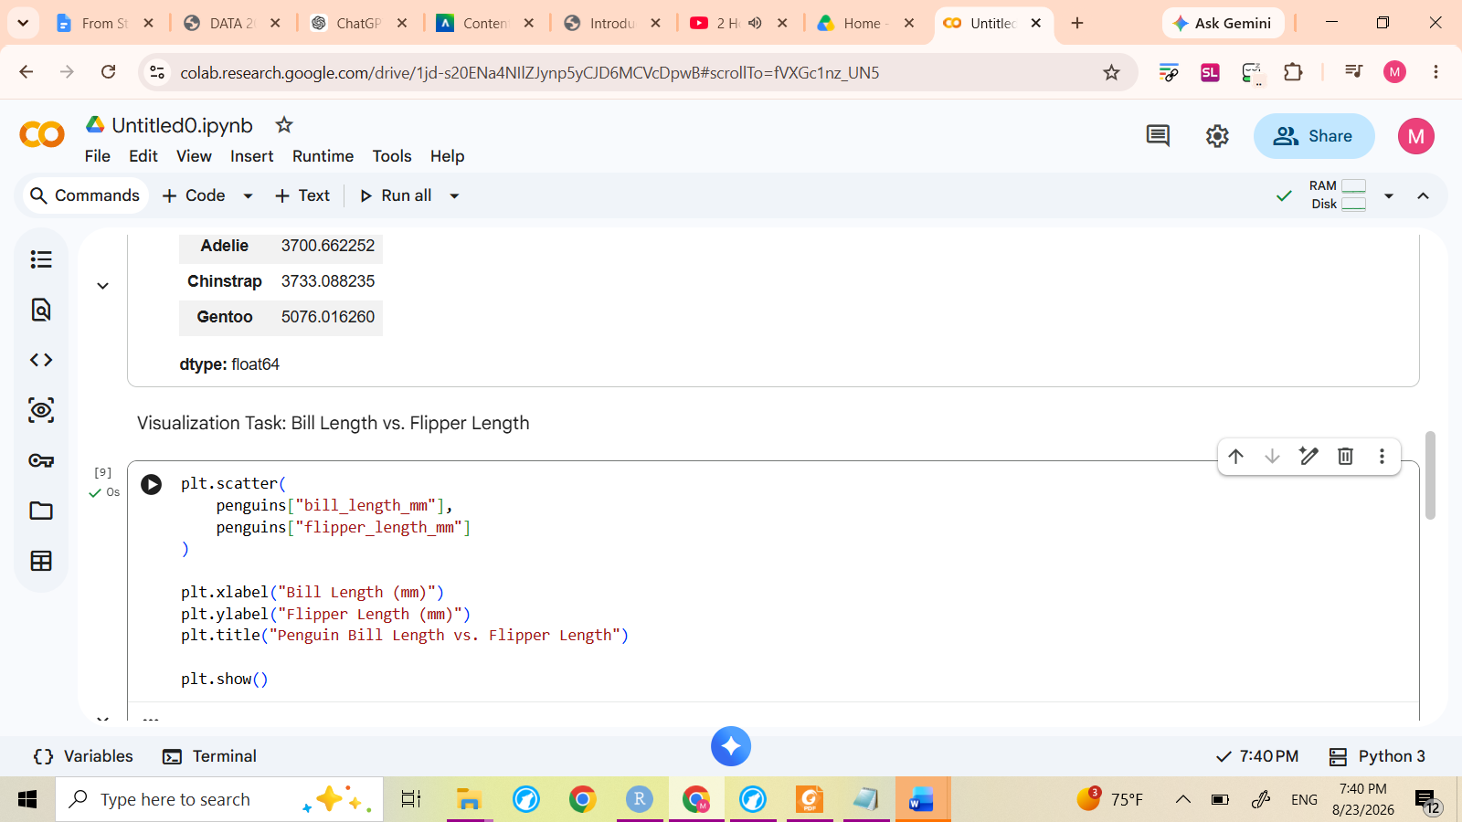
Finally, change the name of your notbook. At the top of the Colab window, rename your notebook to “week1-lab”. The “.ipynb” extension identifies the file as a Jupyter notebook.

Step 5: Save Your Colab Notebook to GitHub
Now you will connect your work in Google Colab with your GitHub repository. From the Colab menu, select: File → Save a copy in GitHub
The first time you do this, Google Colab may ask for permission to access your GitHub account. Follow the prompts to authorize the connection.
- Select your: DATA201-labs repository.
- Use the filename: week1-lab.ipynb
- You may also enter a commit message such as: Add first Colab notebook
- Select OK to save the notebook to GitHub.
Your Colab notebook is now stored in your DATA201-labs GitHub repository.

Step 6: Verify Your Work on GitHub
- Return to: https://github.com
- Open your DATA201-labs repository.
- You should now see:
README.md
Week1-lab.ipynb
- Now, select Week1-lab.ipynb GitHub should display the notebook, including the Python code that you created in Google Colab. You should also be able to see the commit message associated with the notebook.
You have now completed your first basic workflow:
Write code in Colab → Save to GitHub → Verify on GitHub
Throughout DATA201, you will become more comfortable using these tools together as part of a reproducible data science workflow.

